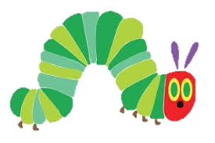
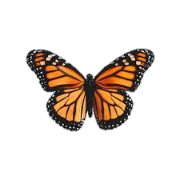

Understanding the World
- The life cycle of a butterfly and frog
- I can Make observations about animals and plants discussing similarities and differences using photographs and real experience.
- How does the weather effect plants growing outside?
- How do we plant a seed?
- Eid, Vaisakki, Easter

Communication and Language

- I can retell a story and follow a story with pictures or props.
- I can respond to what I have heard by explaining my thoughts and saying what I think

Maths

- Automatic recall of number bonds
- Introducing a new resource – rekenrek
- Counting things that cannot be seen

Writing
- I can write instructions
- I can re-tell a story
- I can label a diagram
Key Theme Spring 2
Growing and Changing



Expressive Arts and Design
- I can create 3D sculptures using air dry clay. We can create the different stages of the butterfly lifecycle – egg, caterpillar, cocoon, butterfly.
- I can explore the use of different materials to make art and explain my choices
- Observational drawings of flowers and plants.

Personal, Social and Emotional Development
- I can understand the importance of eating a balanced diet.
- I can verbalise my feelings and identify ways to help myself
- I can recognise how others are feeling and respond accordingly.
Physical Development
.
- Participate in complex fine motor skill activities to strengthen muscles in hands and develop movements to aid fluency and accuracy with writing.
- Forming most letters in the correct way
- PE – Tennis

Reading
- As a class our key texts will be The Hungry Caterpillar, One Little Frog, We Found a Seed and The Enormous Turnip.

- I can access the phonics provision independently to support new phonics skills.

