Dates for diary
- Parents evening 10/11th February

Revision books
The children will be receiving SATs revision books covering maths and grammar activities alongside weekly reading comprehensions that we cover. We hope that you will support your child by encouraging them to continue to read widely and to complete the work that we send home. The aim of these activities is to provide further opportunities for your child to practice the learning that is going on in school and to highlight gaps in learning that we need to address.
YEAR 6 – SPRING TERM 2025
We hope you all have had restful and enjoyable break and we welcome you back to the new year. This is a very important term in Year 6, for it is from this point that we will begin to focus on the requirements of the SATS. In the next few weeks, we will be holding a parent’s SATs meeting to share the processes that the SATs will entail and how we at Launde are going to implement the tests. We feel it is very important not to overwhelm the children or overplay the importance of one test. We have embraced changes within our curriculum, to provide the best learning experience we can offer for our children.

ENGLISH
Our lessons this half term will be based on the book ‘Wild Boy’, by Rob Lloyd Jones. Through this text, we will cover a full range of writing styles and literacy requirements including:
- Description of characters
- Action Scene
- Newspaper report
Skills include:
- Indirect and reported speech
- Time adverbials
- Figurative language
- Different punctuation for parenthesis
In the second half of the term, we will focus on the book ‘Pig Heart Boy, by Malorie Blackman. We will cover the following writing styles:
- Dialogue
- Informal letter
- Balanced Argument

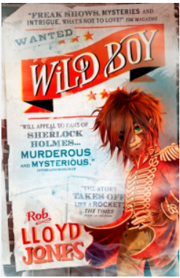

DESIGN & TECHNOLOGY

Structures: Playgrounds

In the second half term, children will research existing playground equipment and their different forms, before designing and developing a range of apparatus to meet a list of specified design criteria.

Homework
Homework is assigned each week and is required back by the following Thursday. It is important that children complete their homework and bring it in on the date required, so we are able to mark this as a class. Children are given paper copies of their homework, as well as a copy uploaded onto teams each week.


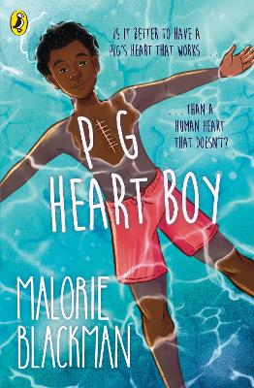
PE
Monday- Indoor PE
Our PE topics include: multi skills and WWII dance.
Friday- Outdoor PE
Our outdoor PE topic includes: football. Children are allowed to wear football boots for outdoor football.

MATHS
Everyday children will practise and continue to develop oral and mental skills including, counting, mental strategies, rapid recall of +, -, x and÷ facts.

This term, we will start with Imperial and metric measures before moving onto decimals, percentages, ratio and proportion. Children will learn:
- Multiplying one-digit numbers up to 2 decimal places
- Use written division methods which involves 2 decimal places
- Recall using equivalences between simple fractions, decimals and percentages accuracy.

Alongside daily maths lessons, children will complete a weekly mental arithmetic test to practise to help recap their previous learning and build up their pace.

SCIENCE
This term, we have two science topics to complete. The first topic is all about light. Children will learn and explore how light travels in straight lines, how shadows are formed and change and which materials can reflect light more easily. Within this topic, children will have plenty of hands-on experience of creating shadows using torches and measuring shadows.

In our second science topic, children will explore the topic further classification. Within this topic, children will learn to classify organisms based on their characteristics. This topic links closely to their previous unit on evolution.



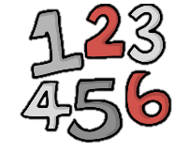


HISTORY AND GEOGRAPHY
What was the impact of World War 2 on the people of Britain?
Investigating the causes of WW2; learning about the Battle of Britain; investigating the impact of the Blitz and evacuation on people’s lives; and evaluating the effectiveness of primary sources.

Where does our energy come from? (Second half term)
Learning about renewable and non-renewable energy sources, where they come from and their impact on society, the economy and the environment.
ART
Make my voice heard
From the Ancient Maya to modern day street art, children will look at how artists convey a message. They will explore imagery, symbols, expressive mark making. Children will consider audience and impact, to create powerful drawings, to make their voices heard.
R.E.
- Beliefs about creation
- Easter
SPANISH
COMPUTING
Programming – variables in games
Understanding variables in games, designing and improving their own games through coding.

Data and Information- Introductions to spreadsheets
Exploring spreadsheets and learning how to input data onto a spreadsheet.

