Homework
Children in Year 5 will continue to be set a weekly maths homework, and weekly multiplication practise on Times Table Rockstars.
They will also continue to be set a creative homework every fortnight – this gives one week for planning and research, and one week for creating. We have been really impressed with the quality of homework so far – keep it up Year 5!

Year 5 – Spring Term 2024
Welcome to the exciting adventures that await our Year 5 students in the upcoming Spring Term! As we embark on this journey of learning and discovery, our dedicated team is thrilled to share with you an overview of the engaging and enriching curriculum we have planned for your children. We look forward to working collaboratively with you to create a positive and supportive learning environment for our Year 5 learners. Together, let's make this term a time of growth, exploration, and academic success!
Mr Frost, Mrs Johal and Miss Patel


Writing
This term we will be producing various pieces of written work, based on two books – one of which will be kept a secret for now... The text types we will write include:
- Informal letters
- Newspaper report
- Narratives (action scenes and dialogues)
- Comparative reviews
Each written piece will have different grammar focuses which the children will be learning and exploring. They will include:
- Present progressive verb tenses
- Relative clauses
- Homophones
- Speech
- Adverbs
- Conjunctions
- Extending our use of vocabulary and sentence starters.

Key Dates

School Trip to a local Mosque – 20th January
Speedwell Assembly – 14th March
Rivendell Assembly – 28th March
School Trip to Hunstanton Beach –9th April

Music
In our music lessons with Mrs Tufiq, we will be looking at singing as well as pitch. Within our pitch topic we will be exploring glockenspiels and untuned percussion.

History
In the first half of the Spring term, children will be answering the question: What did the Greeks ever do for us? Children will be taught about the beliefs and lives of ancient Greeks, and will analyse their lasting historical impact, that has helped shape the world we live in today.
Geography
In the second half of the Spring term, we will move onto a new Geography topic – Why do oceans matter? In this topic Year 5 children will learn about the importance of oceans in the world’s eco system, and what we can do to help prevent these important environments from being damaged.

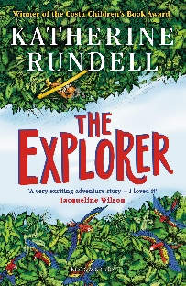


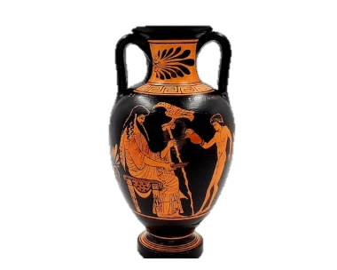

English - Reading
Children in Year 5 will receive daily reading lessons, exploring both fiction and non-fiction texts. This will take the form of a “reading journey” each week, and cover a range of reading skills, including: vocabulary, inference, prediction, explanations, summarising and sequencing (VIPERS).


Science
Year 5 will continue to develop their scientific enquiry skills with weekly science lessons. Over the course of this term, we will explore two key units:
Life Cycles (Biology) – Children will study a variety of sexual and asexual lifecycles focusing on animals and plants. They will find similarities and differences through comparisons and understand how new life and plants are created.

Human Development (Biology) – Children will link their prior knowledge of lifecycles to a human lifecycle and the different stages. They will apply their understanding of gestation to humans and explore human development including the development of embryo and foetus. To apply their learning and extend their scientific skills, the children will collect data and represent in graphs and tables. Later in the term children will address the stage of puberty, highlighting the difficulties when approaching the later years of life.

Maths
Children in Year 5 will continue to receive continuous maths lessons throughout their time in school, with a focus on reasoning and problem-solving skills. Children will be taught to use
mathematical vocabulary to explain their methods and apply this to a variety of real-life inspired problems. Below is an overview of the topics to be covered in Year 5 this term:

Multiplication and Division – multiplying and dividing 4-digit numbers by 2- and 3-digit numbers, including remainders.
Decimals and Percentages – expressing numbers to 4 decimal places, understanding what percentages represent, converting between decimals, percentages and fractions,
Measure – Perimeter and Area – perimeters of rectangles, rectilinear shapes and polygons; areas of rectangles and compound shapes.
Graphs and Tables – drawing and interpreting line graphs and two-way tables.

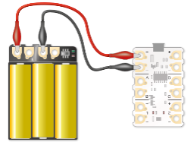



Computing
In our weekly computing lessons, we will continue to develop children’s IT literacy. This term we will cover:
Programming – use physical computing to explore the concept of selection in programming through the use of the Crumble programming environment.
Data and Information – How flat file databases can be used to organise information in records.
eSafety – Computing lessons will be supplemented with regular points of discussion regarding how to stay safe online, and how to deal with adverse online situations.

Art and DT
In weekly creative lessons, children will study the following topics:
Electrical Systems: Doodlers - This unit encourages the pupils to problem-solve and understand a product’s construction before developing their own.
Drawing: I Need Space - This unit focuses on understanding retrofuturism, developing skills in evaluating images and creating art through various drawing processes.
PE
Children will focus on the following sports and activities:
Indoor: Multi-skill and Mini Muay Thai
Outdoor: Football and Kwik Cricket

PE days in Year 5 will remain on Wednesdays and Thursdays – please wear appropriate uniform on these days.

R.E.
In RE children will continue to develop mutual respect and tolerance of others cultures and beliefs. The following topics will be covered this term:

Beliefs in God – Why do some people believe in God and some people not?

What would Jesus do? – What lessons can be learnt from the teachings of holy figures?

Spanish
Children will be exploring how to hold and maintain a conversation about the weather and environments.

