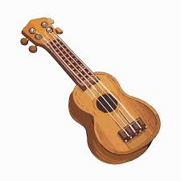
Year 4 – Spring Term 2025
We hope you all have had a safe and restful break. We welcome you back to our exciting Spring term. We do appreciate the support you have given and continue to give as we explore new challenges and interesting topics in Year 4.
Mrs Frost, Mrs Melody and Mr Patel

Reading
Throughout the Spring term, we will continue to focus on strengthening our reading skills through a diverse range of texts, including fiction, non-fiction and poetry. To support this, we will be using VIPER-style questions (Vocabulary, Inference, Prediction, Explanation, and Retrieval). This approach helps students engage more deeply with texts by improving their vocabulary, encouraging them to make inferences, predict outcomes, explain their reasoning, and retrieve specific details from the text. By incorporating these question types, students will enhance their ability to analyse, discuss, and interpret what they read.
To support your child, please listen to them read as often as possible and ensure they understand what they have read. Our main focus is to continue to enrich and increase their vocabulary depth and range. The children should be encouraged to use ideas and vocabulary they have read in their own writing.
Music
The children will continue to develop their skills of playing the ukulele.

PE
In Spring 1, indoor Gymnastics incorporating sequenced, matched and mirrored movement which will enhance core body strength and control. Outdoor will be non-contact tag rugby which includes passive and active defence as well rule following. Spring 2 will see the children enjoy self-defence using a variety of hand and foot strikes using the principles of control and respect. Outdoor will be leadership through creating a passing game to organising a team.
English

For the first half of the term, we will continue to base our writing on ‘The Iron Man’ by Ted Hughes which will explore characterisation and journalistic reporting. This will be followed by Maria Farrer’s ‘Me and Mr P: Joe’s New World’ which will be used to explore the use of recount, dialogue and biography. In this term’s writing we will further develop the children’s writing techniques by practising how to use:

modified adjectives, adverb pairings, prepositions, onomatopoeia, time adverbials, past tense verbs, inverted commas for speech, possessive apostrophe use, reflective questions and relative clauses.

Spellings
The children will be consolidating their use of the Year 3/4 common exception words through targeted spellings in all writing tasks. We will focus on morphology to show how words are formed to create meaning from the root word and the use of prefixes and suffixes.
Spelling rules for the term:
- dropping e when adding ‘ed’ or ‘ing’
- doubling a consonant when adding a suffix
- combining the prefix and a root word
- adding ion suffix
Oracy
We will continue to practise fluent expression through the organisation of ideas, listening and responding effectively to allow the transfer of thoughts and information to others.

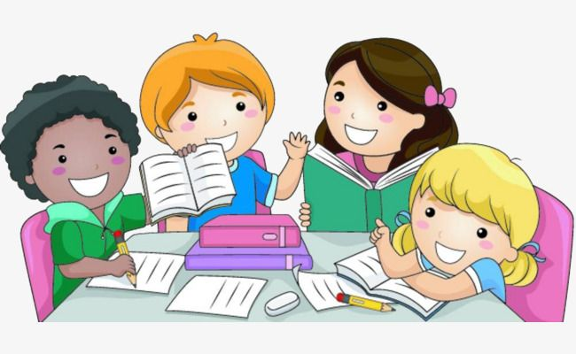


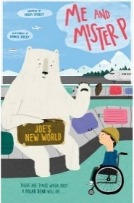
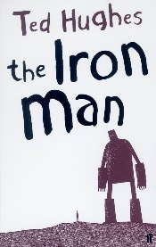
Homework
Homework will be set on a Friday each week via Teams. Maths homework will be based upon the topics that we cover in the lessons to consolidate learning and understanding. There is an expectation that each child will complete Times Table Rock Stars on a weekly basis to aid rapid recall of all times tables.


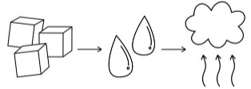
Science
States of matter
Children will compare and group materials together, according to whether they are solids, liquids or gases. We will observe that some materials change state when they are heated or cooled, and measure or research the temperature at which this happens in degrees Celsius (°C). They will also identify the part played by evaporation and condensation in the water cycle and associate the rate of evaporation with temperature.
Sound
Children will identify how sounds are made, associating some of them with something vibrating. They will recognise that vibrations from sounds travel through a medium to the ear. We will find patterns between the pitch of a sound and features of the object that produced it. Patterns between the volume of a sound and the strength of the vibrations that produced it will be found. We will also recognise that sounds get fainter as the distance from the sound source increases.

Maths
Every week, we will spend some time in the mornings learning our multiplication tables using Times Table Rock Stars.
Throughout all units of work the children will practise their fluency, reasoning and problem-solving skills.
This term, we will cover these topics:
Multiplication and Division
- Using formal written methods for multiplication – short multiplication
- Using formal written methods for division – short division commonly known as the bus stop method
Length and Perimeter
- Converting between kilometres and meters
- Find perimeters of shapes
- Work out missing lengths and find solutions involving perimeter
Fractions
- Find non-unit fractions of 2-digit and 3-digit numbers
- Find equivalent fractions and use them to simplify fractions
- Compare and find equivalents fractions and decimals
Decimals
- Recognise, use, compare and order decimal numbers to 1 decimal place
- Recognise that decimals are tenths and hundredths
- Round decimal numbers to the nearest whole number
- Solve simple money problems with decimals to two decimal places

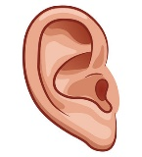


Art
Children will be developing skills in colour mixing, focusing on using tints and shades to create a 3D effect. They will experiment with composition and applying painting techniques to a personal, still life piece.
History
This term, children will be learning about how hard it was to invade and settle in Britain. They will focus on Viking raiders and the Anglo Saxons and Scots. They will be assessing their contribution to modern Britain.

This term, children will be learning about how hard it was to invade and settle in Britain. They will focus on Viking raiders and the Anglo Saxons and Scots. They will be assessing their contribution to modern Britain.
Key Information
Parents’ evening: 10th and 11th February.
Scholastic book fair: 6th to 11th February
Silverstone Trip: 13th February
Gurdwara Visit: Monday 17th March (to be confirmed)
Dates for Condover Hall: Tuesday 1st – Friday 4th April.
Children should wear their PE kits to school on Monday and Tuesday.
Please ensure all hair is tied up, nails are clear of varnish and school uniform is labelled clearly.
Geography
Children will learn where our food comes from. They will be able to explain how our food choices impact the environment, understand the importance of trading responsibly, calculate the distance food travels, collect data to determine the origins of our food, and discuss the advantages and disadvantages of buying local versus imported food.
Computing
We will focus on Programming: Repetition in Shapes, where learners will plan, modify, and test programs to create shapes and patterns using the Logo programming language. They will explore how repetition can simplify coding and enhance creativity.
Children will also investigate how data is collected over time using sensors. They will consider how humans experience the environment through their senses and how computers can monitor conditions using special input devices.

Spanish
Children will show understanding of a range of familiar phrases which is based upon places within a town and to be able to give directions. The children will also consolidate their knowledge of numbers to 20 (out of order) and continue 10s up to 100.

R.E
Children will be learning about Sikhism and will look at the key aspects of Sikh worship and what Sikhs believe in. Children will also learn about Easter and why Christians called the day Jesus died Good Friday.

