READING
In the Spring term, your child will continue to be given two new reading books, which we expect them to read and discuss with an adult at home over the course of the week.

YEAR 2 – SPRING TERM 2025

Welcome back and happy new year! We hope you have had a restful break and are ready for an exciting new term of learning.
We were incredibly proud of how well the children settled into Year 2 and how hard they worked throughout the Autumn term. We can’t wait to share this term’s exciting topics with everyone and look forward to working in partnership with you to ensure that your child has a happy and successful term.

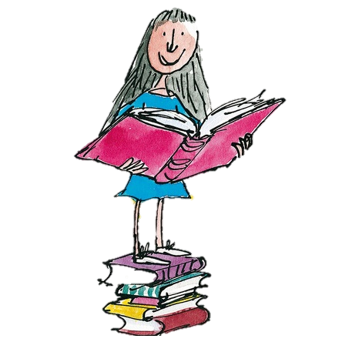
Please listen to your child read every day. It is also beneficial to ask questions about the book to develop their comprehension skills.

During our daily reading lessons pupils will be expected to read fluently using expression. We will be specifically teaching the skills: Vocabulary, Inference, Prediction, Retrieval, Summarising, Sequencing and Explanation.

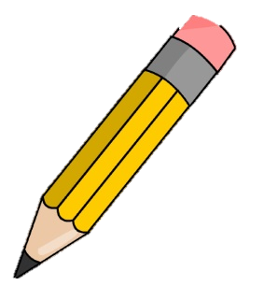
ENGLISH
We will be using a range of media to develop children’s speaking, listening, reading and writing skills. This will include:

- The Day The Crayon’s Quit- present tense, setting description, letters
- The Dark- recount and setting description.
- Colour Poems- What is Pink?

The children will continue to use a range of punctuations, including question marks, exclamation marks and commas in a list. This term, they will practice using different styles of sentences and continue to use varied and adventurous vocabulary.

PE
During PE, the classes will learn basic rugby skills They will learn important team work skills through a variety of outdoor games.

In dance, the children will be working on movement and sequencing linked to the theme of space.

Children are required to come to school in their P.E kit on Tuesday and Thursday. For health and safety, no jewellery should be worn on these days. If your child has their ears pierced please make sure that they are covered with micropore tape. Please ensure that children have long hair tied up.

HOMEWORK
Homework is an opportunity to consolidate what they have learnt at school. It will be given out each Friday electronically on Teams and will need to be completed by the following Thursday.

SCIENCE
Everyday Materials
This term, the children will enjoy learning about materials, their uses and their properties.
They will:
- Identify & compare the suitability of a variety of everyday materials, including wood, metal, plastic, glass, brick, rock, paper & cardboard for particular uses.
- Find out how the shapes of solid objects made from some materials can be changed by squashing, bending, twisting & stretching.

MATHS
Every day the children will practise and develop oral and mental skills. In groups and independent work, we will be covering the following skills and using them to deepen the children’s mathematical understanding:

- Money- understanding the value of pounds and pence.
- Using the four operations (+ - x ÷) to solve problems.
- Measures – length, height, mass, capacity and temperature.
- Fractions – finding ½, ¼, 1/3 and ¾ of shapes and numbers.

Some useful websites to practise oral and mental maths skills at home include:
https://www.topmarks.co.uk/maths-games/hit-the-button
http://www.snappymaths.com/

HISTORY & GEOGRAPHY

In history we are studying the history of flight. We will be learning about significant historical figures such as the Wright brothers, Bessie Coleman and Amelia Earhart. We will learn about what impact they had. Together we will be helping the children to understand where these events fit into our class timelines, which include the historical figures and events that the children learnt in Year 1. In geography, we will be exploring why our world is wonderful. We will be exploring some of the UK’s amazing features and landmarks. We will be studying our oceans and habitats and our local natural habitats and how we can look after it.


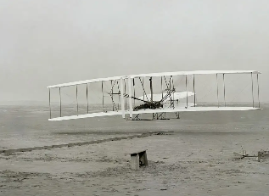

R.E.
This term, the children will continue their learning on Islam. Following this, the children will learn about caring for our world, with particular reference to Christianity and Judaism.

MUSIC
In music this term we will learning about rhythm and pitch. At some point during the term each class will get to develop their musical skills and knowledge of instruments by using the glockenspiels.

ART & DESIGN
In art, we will focus on teaching primary and secondary colours, colour mixing, and creating textures using different tools. We will also explore collage techniques, encouraging children to experiment with materials and evaluate their artistic choices and aims to develop their understanding of colour, texture, and composition in art.

In D&T, after half term, children will be studying cooking and nutrition and looking at the topic balanced diet. Children will learn about the different food groups and how to design and make a wrap.
COMPUTING
In Computing, we will further explore algorithms using a range of technology, including Bee Bots. Children will learn to interpret and make pictograms to display data.

