Understanding the World
- I can draw information from a simple map.

- I can make observations of the world around me using my senses.

- I can create a make-believe map to find Goldilocks.

- I can talk about the different processes needed to make bread e.g., melting and mixing.

- I can talk about the process of making porridge and what it looks like.

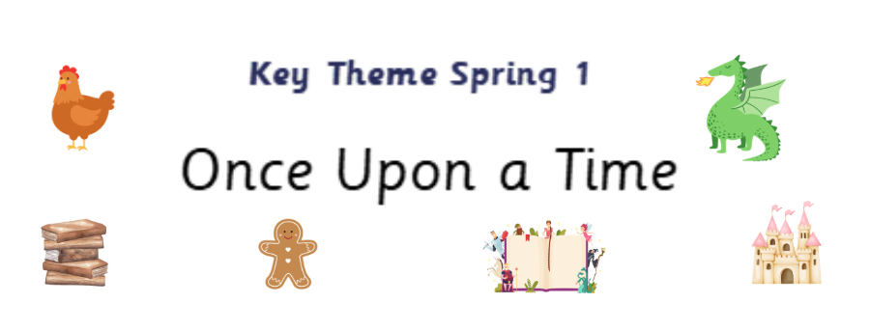



Expressive Arts and Design
- I can explore rhythm through play.

- I can begin to use pictures and images to represent sounds.

- I can keep a steady pulse with some accuracy while playing.

Personal, Social and Emotional Development
- I have the confidence to try something new.
- I can understand the need to have rules in the school and classroom. I can develop the skills needed to manage the school day.
- I can talk about a wider range of feelings and identify how I am feeling.
Communication and Language

- I can use short sentences to explain how I feel.

- I can follow one or two step instructions reliably.

- I can engage in story times and join in with familiar songs and rhymes.

Physical Development
.
- Use tools safely and effectively to create.

- Participate in fine motor skill activities to strengthen muscles in hands and develop movements to aid fluency and accuracy with writing.

Maths
- Focus on 6 and 7
- Compare sets and use language of comparison: more than, fewer than, an equal number to
- Make unequal sets equal
- Focus on the ‘staircase’ pattern and ordering numbers
- Focus on ordering of numbers to 8
- Use language of less than
- Focus on 7
- Doubles – explore how some numbers can be made with 2 equal parts

Writing
- I can write annotate a story map.

- I can write simple instructions.

- I can write a simple character description.
Reading
- As a class, use retrieval and summarising skills to talk about a known text e.g. Cinderella, Goldilocks and The Little Red Hen

- To access the phonics provision to support new phonics skills.

