YEAR 1 – SPRING TERM 2024

We are looking forward to welcoming you all back to school after the Christmas holidays! We hope you have spent some quality time with your families and friends during this break. Hopefully you are now feeling ready for another exciting new term! Mrs Smith and Miss Cox (Rainbow’s End), Mrs Majid and Miss Bedford (Sunburst), Mrs Merz and Miss Frost (Stepping Stones) are all looking forward to welcoming you back to school. Thank you, parents, for your continued support; we look forward to continuing to work with you to best support your children. If you have any queries or questions, please don’t hesitate to contact the office to arrange a telephone appointment.

As a Year 1 team, our first priority is to make sure that every child feels happy, safe and secure. We will continue to do a daily emotion check in, which is checked by the adults in their class. At the start of this term, we will recap behaviour expectations, while also reminding children about our PSHE work on keeping ourselves safe and happy.

As we enter what is often a damp second term, please ensure your child brings a waterproof coat to school with them every day, so that we can continue to learn in and explore our school’s outdoor areas.

Writing
We will be sharing a range of high-quality texts as part of our new writing curriculum! These will include both picture books and poetry books.

We will be learning to write different text types, including:
- Character descriptions
- Setting descriptions
- Innovated stories
- Diary entries
- Instructions
- Poetry

We will continue to focus capital letters, finger spaces and full stops. We will encourage children to sound out unfamiliar words using the phonemes that they have been taught in phonics lessons. We will also be learning about simple conjunctions, exclamation marks and imperative verbs.

PE

During PE, classes will be learning to dodgeball and mini muay thai. In our first unit, they will be developing ball skills, while also learning important teamwork and communication skills. In the second half of the term, we will work on building our personal strength and fitness.

For health and safety reasons, earrings should be removed for PE days. Any earrings that cannot be removed need to be covered with tape. Any religious jewellery, such as bracelets, should also be covered during PE lessons.

Reading
Your child will take part in whole-class reading sessions four times a week this term. We will explore a range of texts as a class and answer comprehension questions. Lots of these sessions will be discussion based. By discussing characters, settings, events and non-fiction information, the children will develop greater comprehension skills including prediction, retrieving information and inference.

Children will receive two books a week to take home and read. One is a phonics book, which children should be able to read independently. Please listen to your child read their phonics book every day. Children will also take home a family reader, which is to be shared with an adult. These books aim to promote a love of reading.





Phonics

In phonics lessons, children will continue learning phase 5 graphemes and harder to read and spell words. In every phonics lesson, children get the chance to apply their new learning. Children will practice reading real and alien words. Supportive phonics resources can be found at the end of this document.



Homework
Homework is an opportunity to consolidate what children have learnt at school. Please ensure you read your child’s phonics book with them every day as part of their homework.

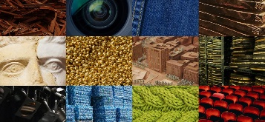
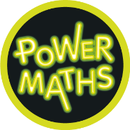
Maths

Every day the children will practise and develop oral and mental skills e.g. counting, mental strategies and rapid recall of number bonds. In groups and independent work, we will be covering the following skills and using them to deepen the children’s mathematical understanding:

- Numbers to 50
- Length and Height
- Mass and Capacity
- Multiplication and Division
- Fractions

Children will be completing work in their Power Maths workbooks in our maths lessons.
Science

This term, our Science lessons will focus on everyday materials.
We will be learning about:
- The difference between materials and objects
- Using our senses to explore materials
- The difference between natural and man-made materials
- Physical properties of materials

We will also be investigating materials, exploring their properties and deciding what makes them suitable or unsuitable.

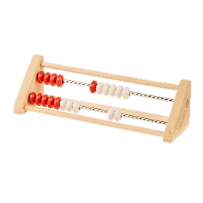
History and Geography

In the first half term, our learning will focus on history. We will be answering the key question ‘how have toys changed?’. This will build on our understanding of our own personal history, which we explored in our last history unit. We will spend time looking at similarities and differences between toys that are popular now and toys that were popular in the past.

After the half term, in geography lessons, children will be exploring the weather. This links well with the learning that we did in science last term about seasonal changes. We will learn to name and locate the four UK countries and recognise our country on a map.


R.E.

Throughout the Autumn term, Year 1 will be exploring the key question ‘what makes some places sacred to believers?’ Children will have the opportunity to talk about their own religious beliefs. This is a fantastic chance for us to celebrate our diversity and to share our own experiences and beliefs in a respectful way.

Art and D.T.

In D.T. lessons, we will be making our own puppets! Children will explore different joining methods of fabrics and will be able to decide on their own individual puppet design. Children will have a number of choices to make and justify as part of the puppet making process.

In Art, children will be using paper to create sculptures and 3D models. Children will roll, shape, fold, construct and paint as part of this unit.

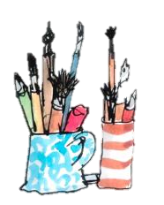
Computing
Initially, we will complete a unit that develops our programming skills. We will explore using simple commands for beebot robots to follow. We will begin to predict the outcome of commands. In the second part of the term, we will explore data and information. In particular, we will look at counting and sorting information.
Music
Music this term focuses on rhythm. We will learn about the difference between rhythm and pulse. We will also begin to use some graphic notation to show rhythm. Children will listen to and respond to many different songs and styles of music through short, weekly music lessons.



