Year 4 – Autumn Term 2024
We hope you all have had a safe and restful break. We welcome you back to our exciting Autumn term. We do appreciate the support you have given and continue to give as we explore new challenges and interesting topics in Year 4.
Mrs Frost, Mrs Melody and Mr Patel

Reading

Our continued focus is for the children to enjoy the books that they read and appreciate how the author has engaged the reader through the use of exciting vocabulary. Parents are encouraged to challenge their children’s ability of reading between the lines (inference skills) to fully understand the text.
To support your child, please listen to them read as often as possible and ensure they understand what they have read. Our main focus is to continue to enrich and increase their vocabulary depth and range. The children should be encouraged to use ideas and vocabulary they have read in their own writing.

Homework

Homework will be set on a Friday each week via Teams. Maths homework will be based upon the topics that we cover in the lessons to consolidate learning and understanding. There is an expectation that each child will complete Times Table Rock Stars on a weekly basis to aid rapid recall of all times tables.

Writing

For the first half of the term, we will be using the text, Rumaysa a Fairytale by Radiya Hafiza as our focus for our Writing lessons.
We will be writing in many different styles which require different skills such as:
Setting description: Using similes, metaphors, personification, fronted adverbials in a narrative style.
Diary writing: Using past tense verbs and reflective questions
For the second half of the term, we will be using two texts, The Tin Forest by Helen Ward and The Lost Thing by Shaun Tan as our focus for our English lessons.

We will be writing in many different styles which require different skills such as:
Setting description: Using figurative language, personification and prepositional phrases.
Use of adverbs: Creating effective sentences
Use of present tense verbs: Creating effective sentences
Use of resulting conjunctions: Creating effective sentences

The children will be consolidating their use of the Year 3/4 common exception words as well as continuing to practise their use of prefixes and suffixes.



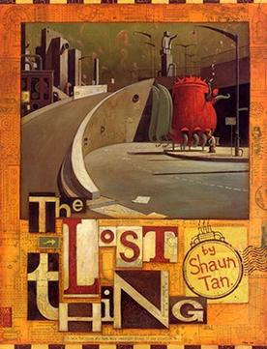
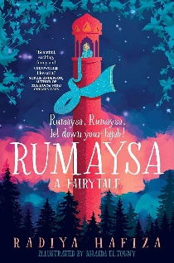
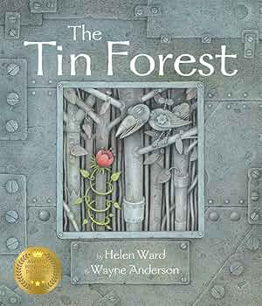
PE
For indoor PE, the children will be focusing on fitness and multi-skills which will involve developing balance, agility and coordination.
For outdoor PE, the children will develop their skills in basketball and football. This will include working on their throwing and catching skills, coordination and communication.

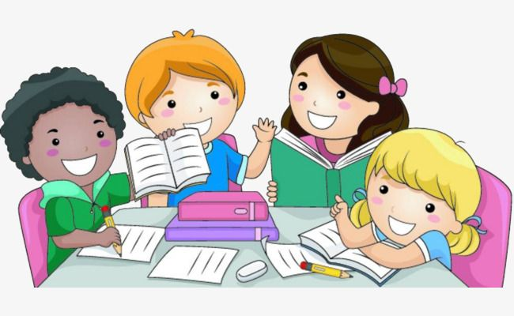

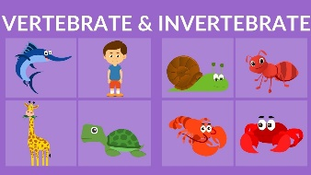
Maths
Every week, your child will practise their rapid recall of multiplication tables using Times Table Rock Stars in preparation for their National Multiplication Tables Check.
Topics for autumn term are as follows:
Place value
-Recognise four-digit numbers
-Partition four-digit numbers flexibly
-Order four-digits on a number line
-Estimate on a number line to 10,000
-Compare and order numbers to 10,000
-Round to 10, 100 and 1000.
Addition and subtraction
-Add and subtract 1s, 10s, 100s, 1000s.
-Adding/Subtract four-digit numbers
-Adding/Subtract four-digit numbers with an exchange
-Estimating answers
-Checking strategies
- Problem solving
Multiplication and division
-Multiples of 3/6/9/7
-Multiply by 1 and 0
-Multiply/divide by 1 and itself.

Science - Biology
Classifying organisms
-Children will recognise that living things can be grouped in a variety of ways.
-They will explore and use classification keys to group organisms in their environment.
-Children will recognise that environments can change which can pose dangers to living things.
Food and digestion
Children will explore the types of human teeth and their use and how the human digestive system works

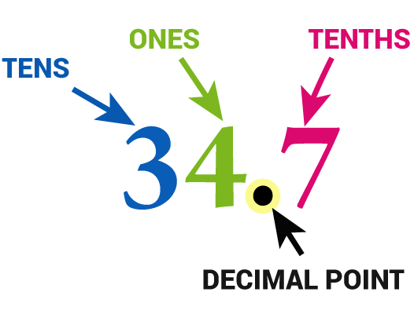
Key Information
PE days are on Monday (outdoor) and Tuesday (indoor).
Children should wear their PE kits to school on Monday and Tuesday.
Please ensure all hair is tied up, nails are clear of varnish and school uniform is labelled clearly
Trip to Brocks Hill: Thursday 31st October 2024

History
This autumn the children will be compare different periods in History and will examine how children’s lives have changed.
Design and Technology & Art
In Design and Technology, children will be focussing on cooking and nutrition and evaluating the effect of when a recipe is adapted.
In art, will be focusing on drawing with the use of power prints to give proportion, tone and depth.
R.E
Children will learn about Hinduism in Britain today in the first half of the term. In the second half of the term the children will learn about The Trinity.

Computing
Children are going to be learning about the internet, connecting networks. The children will also learn the importance of security and the use of passwords.

Spanish
In Spanish, the children will be exploring the names for food and drink. Children will understand Spanish names for town landmarks and will be able to give direction to places.
Music
The children will learn to play the ukulele and learn key notes.

Geography
Children will be learning about the importance of rainforests, where they are, why they are changing and the impact that may have. Children will also explore our local woodland using a variety of date collection methods.

