YEAR 6 – AUTUMN TERM 2024
Welcome to the final year of your child’s time at Launde Primary School. Our purpose over the year is to prepare your children for their transition to secondary school as well as the S.A.Ts examinations, which will take place in May.
Within this term, each of the three classes will have their class assembly, celebrating the curriculum, the time of harvest and Children in Need.
We look forward to working with you to ensure the children have an enjoyable and productive year.
The Year Six team

Autumn Term Trips
- Twycross Zoo
- Warning Zone
- Pantomime
Music
This term, children will explore pulse and rhythm, whilst performing on a variety of musical instruments. They will learn about different types of musical notation and the values that notes have in musical scores.



Homework
Maths homework will be given weekly to reinforce what has been taught in class so that the children are given an extra opportunity to practise a skill.

Class homework will be given out every two weeks. This will be focused on the foundation subjects.
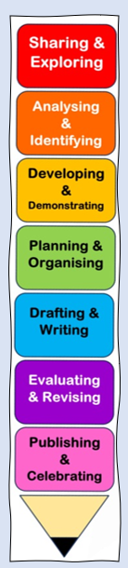
ENGLISH
In the first half of this term, will be looking at ‘The Infinite’, written by Patience Agbabi. From this book, we will ask the children to write:
- A recount, in the form of a diary
- A persuasive text, in the form of a brochure
- A short piece of narrative, describing an action scene.
In the second half term, we will be studying another fictional book (the name has been omitted, as it forms part of our first lesson, where the children make predictions about the book based on the front cover). Children will create:
- A narrative that describes the setting
- A non-chronological report about refugees
- A formal, persuasive letter.

Art
Craft and design: Photo opportunity
Developing photography skills and techniques to design a range of creative photographic outcomes.

PE
Indoor
- Fitness
- Gymnastics

Outdoor
- Basketball
- Tag Rugby




MATHS
The mathematical focuses for this term will allow the children to recap their prior knowledge as well as allowing them the opportunity to apply new knowledge taught to them in a variety of different ways. The topics that will be covered this term are:

- Place Value
- Addition
- Subtraction
- Multiplication
- Division
- Fractions
- Measure

SCIENCE

Physics: Electricity
Children will learn the individual components of a circuit, including their given symbols and learn how to create different circuits.

Biology: Evolution
In this topic, we will be learning about how organisms adapt to the environments that they live in, variations and natural selection.


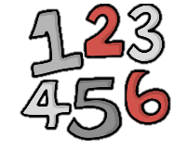

R.E.
- Jewish beliefs
SPANISH
- Physical descriptions
COMPUTING
Computing systems and networks - Communication and collaboration
Children will learn how computers and people communicate effectively with each other safely.

Unit 2 - Creating media - web page creation
We will be looing at the construction of websites and the features that they offer.
HISTORY AND GEOGRAPHY
What can the census tell us about local areas?
Investigating local histories from the Victorian to the inter-war period, children explore census records. They learn about the census, its purpose and its changes over time.
Why does population change?
Investigating why certain parts of the world are more populated than others; exploring birth and death rates; discussing social, economic and environmental push and pull factors; learning about the population in Britain and its impacts.
Design and Technology
Textiles: Waistcoats
Using a combination of textiles skills such as attaching fastenings, appliqué and decorative stitches, children design, assemble and decorate a waistcoat for a chosen purpose.

