YEAR 3 – AUTUMN TERM 2024
We would like to welcome you and your child to Year 3. This year is going to be a new beginning in Key Stage 2 and we hope that it will be a rewarding year for your child. We strive to include structured lessons that will challenge your child to develop independence and resilience. We cannot wait to start this new year, full of exciting opportunities.
Miss Parker, Mrs Gandwan and Mrs Nerney (Year 3 teachers)

MATHS
Everyday children will practise and develop their fluency and arithmetic skills which include: counting, times-table facts and rapid recall of number bonds.

They will cover these topics:
- Place value
- Number addition and subtraction
- Multiplication and division

Additionally, the children will take part in:
- TT Rockstars
- Arithmetic challenges
- Problem-solving & reasoning activities
- 5-a-day Maths questions
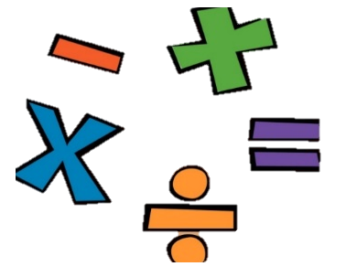

WRITING

Using our new Pen to Paper curriculum, this term we will mainly be focussing on improving our narrative writing. We will attempt to retell a story from another character’s point of view as well as creating and describing a whole new world. Children will also have an opportunity to work on character descriptions and their very own action scene!

Additionally, there will be an opportunity for a non-fiction piece of writing with a non-chronological report.

READING
Areas we look to improve in reading, include:
- Reading fluency.
- Retrieval and recalling information from the text.
- Understanding of a piece of text.
- Making sound predictions of what might happen next.
To support your child please ensure you listen to your child read as often as possible to assist in continuing to make progress. It is important to discuss the text and ask questions to further your child’s understanding of what they have read.

TRIPS
- October - Beaumanor Hall – Iron Age and Celt Day

- November – Hindu Mandir

Parents’ evening dates for your diary:

Monday 14th October
Tuesday 15th October

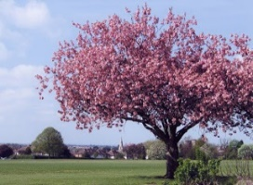

PE
We will be looking to improve basic fitness levels with children carrying out a variety of different bodyweight exercises. In games, children will be able to practise their skills with a ball, sending and receiving with accuracy and building up to team games. The children will also consider the effects exercise has on their bodies and what they can do to improve their own fitness levels both at school and at home.

HISTORY
Children will be studying ‘Prehistory’, focusing on looking at the chronology of mankind, children are introduced to Britain’s story. They will use archaeological evidence to find out about the Stone Age, Bronze and Iron Ages too.
GEOGRAPHY
Children will be learning about volcanoes and why people live near them. The children learn that the Earth is constructed in layers, and the crust is divided into tectonic plates. They study the formation and distribution of mountains, volcanoes and earthquakes and use Mount Etna to identify how human interaction shapes a volcanic landscape.
SCIENCE
Our science lessons will consist of practical activities and investigations, that the children are guaranteed to enjoy whilst learning important information. We will be covering two topics this term.
Rocks (chemistry)
Children will be taught to compare and group together different kinds of rocks on the basis of their appearance and simple physical properties. They will be able to describe in simple terms how fossils are formed when things that have lived are trapped within rock. Children will investigate and recognise that soils are made from rocks and organic matter.
Light (physics)
Children will learn that luminous objects produce light, that light can be produced by manmade (artificial) sources or by natural sources, and that light travels in straight lines. They look at the formation of shadows and relate this back to their knowledge of light rays.


MUSIC
On a rotating basis, every child will listen to a variety of music and discuss the composition, pitches, tempos and rhythms of different pieces and genres of music.
Striding Top – Diosing with a professional singing coach.
Striding Edge – Rhythm and pulse
Bradgate – Recorders

SPANISH
Children will learn colours, numbers to 20, how to greet each other, the dates of the year and how old they are.
COMPUTING
Children will develop their understanding of digital devices. They will also compare digital and non-digital devices. They will be introduced to computer networks and they will discover the benefits of connecting devices in a network. Children will learn to use ICT devices safely and responsibly promoting E-safety.
RE
Children will learn to answer the question ‘What do Hindus believe God is like?’
ART
The children will review prehistoric paintings in anticipation of creating their own prehistoric artwork.
They will use a variety of materials to do this and make their own paint/colours using natural resources.
DT
The children will learn about castles and their various features. They will design using 2D and 3D shapes before constructing their own castle structure to meet certain design criteria.

KEY INFORMATION
Children should come to school in plain black trainers.

Please ensure all hair is tied up, nails are clear of varnish and school uniform is labelled clearly.

Children should come to school in their PE kits on their PE day. Please remove any jewellery wherever possible.
Our PE days are Monday and Thursday.

