Get, Set, Go!
As a Year 2 team, our first priority is to make sure that every child feels happy, safe and secure coming into their new class. To enable us to do this, we have a daily emotional check in which the children complete. There are worry monsters in the classroom which the children can use to write down their worries for the monster to gobble up! We have begun the term with a number of activities to help to build trusting relationship with the children in order to help them to feel confident speaking to us about anything that concerns them.

YEAR 2 – AUTUMN TERM 2024
We would like to take this opportunity to welcome you and your child/children to Year 2. We hope you have spent some quality time with your families and are now ready for an exciting new term of learning. Our team this year consists of Mrs Allen (Bramblewood), Miss Stewart (Swiftwood) and Miss Tobin (Bosworth). Mrs Barker, Miss Barnes and Mrs Warrington will also be joining the Year 2 team and supporting the children. We are looking forward to working in partnership with you to ensure that your child has a happy and successful year. If you have any queries or questions, please don’t hesitate to speak to us or contact the office to arrange a telephone appointment.

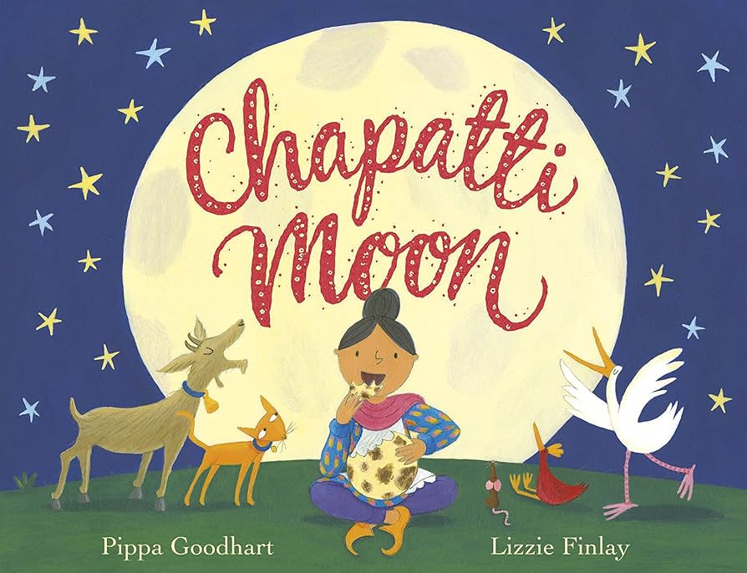
PE
During PE, the classes will be doing gymnastics, dance and pirate fitness during indoor PE lessons and ball games and multi skills in outdoor PE sessions. They will learn important team work and communication skills.

Children are required to come to school in their P.E kit on Tuesdays and Thursdays. For health and safety, no jewellery should be worn on these days. Any earrings that can not be removed need to be covered with tape.

READING
During whole class and individual reading, pupils will be expected to read fluently using expression. They will have daily reading lessons on the same text looking at vocabulary, retrieval, inference, prediction, summary, sequencing and explaining skills.

Children will receive two books a week to take home and read. Please listen to your child read every day. It is also beneficial to ask questions about the book to develop their comprehension skills. If you finish the books ahead of time, there is still value in re-reading the book again to help your child embed new vocabulary. The books will then be changed the following week on a given reading day.

ENGLISH
We will be using a range of media to develop children’s
speaking, listening, reading and writing skills. This will include:

- Chapatti Moon – writing a setting and character description.
- Characteristics of good and bad characters, character and setting descriptions and creating their own alternative tale based on stories they are familiar with.
- Diary entry and letter based on pollution.
- Poetry- simple narrative rhyme linked to the beach.

We will expect the correct use of punctuation and encourage the children to use a range of sentence styles. The children will be taught to use varied and exciting vocabulary, including the use of expanded noun phrases.


Spellings
In the autumn term children will have three weekly spelling lessons. In these lessons the children will have the chance to consolidate the alternative Phase 5 graphemes, including split digraphs, and other alternative spellings for different sounds. They will learn to read and write using the correct spelings.

Homework
Homework is an opportunity to consolidate what they have learnt at school. It will be given out each Friday electronically on Reach My Parents App and will need to be completed by the following Thursday.

SCIENCE

Plant growth
We will be observing and describing how seeds and bulbs grow into mature plants. The children will investigate what plants need to grow and stay healthy.

Needs of animals
This term, the children will enjoy learning more about animals and humans. They will learn about what animals and humans need, including food, water, the right temperature and exercise.

MATHS
Every day the children will practise and develop oral and mental skills e.g. counting, mental strategies, rapid recall number bonds and times table facts. In groups and independent work, we will be covering the following skills and using them to deepen the children’s mathematical understanding:
- Counting, properties of numbers, number sequences and times tables.
- Place value and ordering numbers.
- Using the four operations (+ - x ÷) to solve problems.
- The properties of shape.
- Money.

Some useful websites to practise oral and mental maths skills at home include:
https://www.topmarks.co.uk/
https://ttrockstars.com/


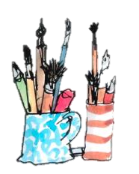
ART AND DESIGN/ DESIGN TECHNOLOGY
In this skilled based subject, children will explore the work of different artists and a skill they have used.

Craft and design: Map it out
Children will use different materials, textures and print to study and create abstract art on the theme of maps.

Structures: Baby bear's chair
Children will look at which materials are the most suitable to make a chair and create their own.

R.E.
Throughout the Autumn term, Year 2 will look at the Muslim faith. We will discuss Islamic celebrations, culture and beliefs.

HISTORY/GEOGRAPHY

How was school different in the past?

Would you prefer to live in a hot or a cold place?

COMPUTING
In the computer suite, we will be exploring IT around us and learning about digital photography. Children will have the chance to use different computing equipment during these lessons.

MUSIC
Music this term will help children to learn about rhythm, pitch and pulse when singing, playing, improvising and composing music. We will be taking part in singing assemblies as a key stage, enabling us to listen to different genres of music and learn new songs to perform.

