As a Year 1 team, our first priority is to make sure that every child feels happy, safe and secure coming into their new class. Every morning, children do an emotion check in, which is checked by the adults in their class. We use the first few lessons of the Autumn term to remind children of behaviour expectations in the class with an emphasis on keeping ourselves safe and happy. The transition to Year 1 is supported by the use of continuous provision in the afternoons, so that children can continue to learn in a way that they’re familiar with from EYFS.

Please ensure your child brings a waterproof coat to school with them every day, so that we can continue to learn in and explore our school’s outdoor areas.

YEAR 1 – AUTUMN TERM 2024

We would like to start by welcoming you and your child to Year 1! We hope you have spent some quality time with your families over the summer holidays and are now ready for an exciting new term of learning. Our team this year consists of Mrs Smith (Rainbow’s End), Mrs Majid (Sunburst) and Mrs Merz (Stepping Stones). Miss Frost, Miss Cox and Miss Bedford will also be working in the Year 1 team and supporting the children. We are looking forward to working in partnership with you to ensure that your child has a happy and successful year. If you have any queries or questions, please don’t hesitate to contact the office to arrange a telephone appointment.


Writing
We will be sharing a range of high-quality texts as part of our new writing curriculum! These include:
- Traditional tales
- Picture books

We will be learning to write different text types, including:
- Character descriptions
- Setting descriptions
- A retell of a story
- Postcards

In the Autumn term, we will continue to build on children’s understanding of sentences. We will focus on the key skills of capital letters, finger spaces and full stops. We will encourage children to sound out unfamiliar words using the phonemes that they have been taught in phonics lessons.

PE

During PE, classes will be creating Olympics and Winter themed dances. They will be exploring movement and making different shapes using their bodies. They will learn important teamwork and communication skills. During afternoon break times, children will engage in themed games to develop these skills further. For health and safety reasons, earrings should be removed for PE days. Any earrings that cannot be removed need to be covered with tape.

Reading
Your child will take place in whole-class reading sessions three times a week this term. We will explore a range of texts as a class and answer comprehension questions. Lots of these sessions will be discussion based. By discussing characters, settings, events and non-fiction information, the children will develop greater comprehension skills including prediction, retrieving information and inference.

Children will receive two books a week to take home and read. One is a phonics book, which children should be able to read independently. Please listen to your child read their phonics book every day. Children will also take home a family reader, which is to be shared with an adult. These books aim to promote a love of reading.





Phonics

In phonics lessons, children will begin learning phase 5 graphemes and harder to read and spell words. In every phonics lesson, children get the chance to apply their new learning. Supportive phonics resources can be found at the end of this document.



Homework
Homework is an opportunity to consolidate what children have learnt at school. Please ensure you read with your child every day as part of their homework.

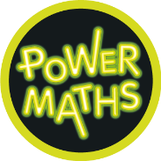
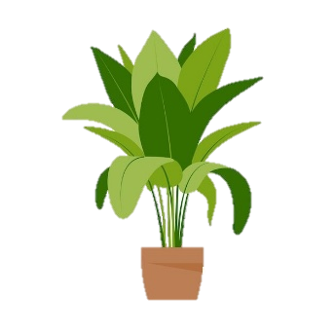
Maths
At the start of the year, we will focus on numbers to 10 in order to ensure that children can confidently form their numbers correctly and represent them in many different ways.

Every day the children will practise and develop oral and mental skills e.g. counting, mental strategies, rapid recall number bonds and times table facts. In groups and independent work, we will be covering the following skills and using them to deepen the children’s mathematical understanding:

- Number and place value
- Addition and subtraction
- Names of 2D and 3D shapes
- Properties of 2D and 3D shapes

Children will be completing work in their Power Maths workbooks in our maths lessons.
Science

This term, the children will enjoy learning more about plants.
We will be learning about:
- Plants as living things
- The structure of plants, including trees
- Deciduous and coniferous trees
Through the continuous provision, children will explore plants in a number of ways and have the opportunity to apply their understanding in new contexts.
Throughout the Autumn term, we will be exploring seasonal changes. Children will learn about the four seasons and what makes each one different.

History and Geography

In the first half term, our learning will focus on history. We will be answering the key question ‘what is my history?’ by exploring different events from a child’s life. We will use key vocabulary, including ‘past’ and ‘present’. Children will also be introduced to timelines, which they will use to plot key events in their own lives. We will also spend time looking at similarities and differences between childhood now and childhood a number of years ago.
After the half term, in geography lessons, children will be exploring our school! We will explore the school grounds and think about improvements that can be made to our play areas.


R.E.
Throughout the Autumn term, Year 1 will be exploring the Christian faith. Our key questions for this term are ‘what do Christians believe God is like?’ and ‘What is the good news that Christians believe Jesus brings?’. Children will also have the opportunity to talk about their own religious beliefs. This is a fantastic chance for us to celebrate our similarities and differences.

Art and D.T.
In D.T. lessons, we will be making windmills! For the first time, children will use a design criteria to make a product with specific specifications. Children will explore different joining methods as part of these lessons.
In Art, children will develop their drawing and mark-making skills. We will use different media to explore mark-making and look at the work of different artists. Children will express themselves creatively using a range of different pens and pencils, allowing them to explore their own unique style.

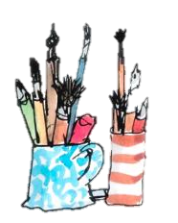
Computing
Initially, we will be exploring technology around us. In the computer suite, children will get used to logging on independently. In the second part of the term, we will begin using the computers to paint digitally. Children will have the chance to use different computing equipment during these lessons.

Music
Music this term focuses on pulse. We will use our voices, bodies and percussive instruments to explore pulse. Children will listen to and respond to many different songs and styles of music through short, weekly music lessons.



